INSTRUCTIONS

THE VARIES USES OF THE FORESTER'S HUT ABOVE RIMSKE TOPLICE

WE POLITELY ASK YOU TO CONSISTENTLY FOLLOW THE INSTRUCTIONS IN ORDER TO REDUCE THE POSSIBILITY OF FAILURES.
FOR FURTHER ASSISTANCE, YOU CAN CALL +386 (0) 30 210 410.

- JACUZZI
Before use: everybody takes a shower without soap.
- Open the cover and place it on the north side of the jacuzzi on the edge of the wood
- To switch on: you press the MODE button press STANDARD press WARM and select the desired temperature between 33 ᵒC and 35ᵒC.
- Blower, Light, Jets 2 keys are available for use.
Enjoy

After use: everyone takes a shower with soap, even if you intend to go to the sauna right after
- Set the temperature to 28 ᵒC with the COOL button.
- Cover the Jacuzzi with the cover.
- Lift the wooden staircase (you can find it before entering the jacuzzi on the south side) and place it in the middle of the cover to protect it from the wind.

- SAUNA
The sauna can be used in two ways: Finnish or Turkish way.
- Everyone always sits on towels
- One light button is used for both applications
- Always take a shower before use (recommended with colder water for better sauna effects). This instruction applies even if you have been to the Jacuzzi right before.
- Turn the sand watch (you find it inside the sauna) and after 10 minutes, turn off the sauna, take a shower, relax and remain still.

THE FINNISH SAUNA
- If you want the Finnish sauna, you use the buttons on the left side of the console (shown in the picture)
- Turn the leftmost key from 0 to the symbol of a lit oven. The symbol should turn red.
- Turn the next button (second from the left) halfway through and the sauna should start heating up.
- When it reaches the temperature of 90 ᵒC, you can set up the towels.
- For steam, pour water into a wooden bucket and spill it on the hot rocks. On the right side in front of the entrance of the sauna you can find various fragrances. If you want, you can put a few drops in the mentioned water.

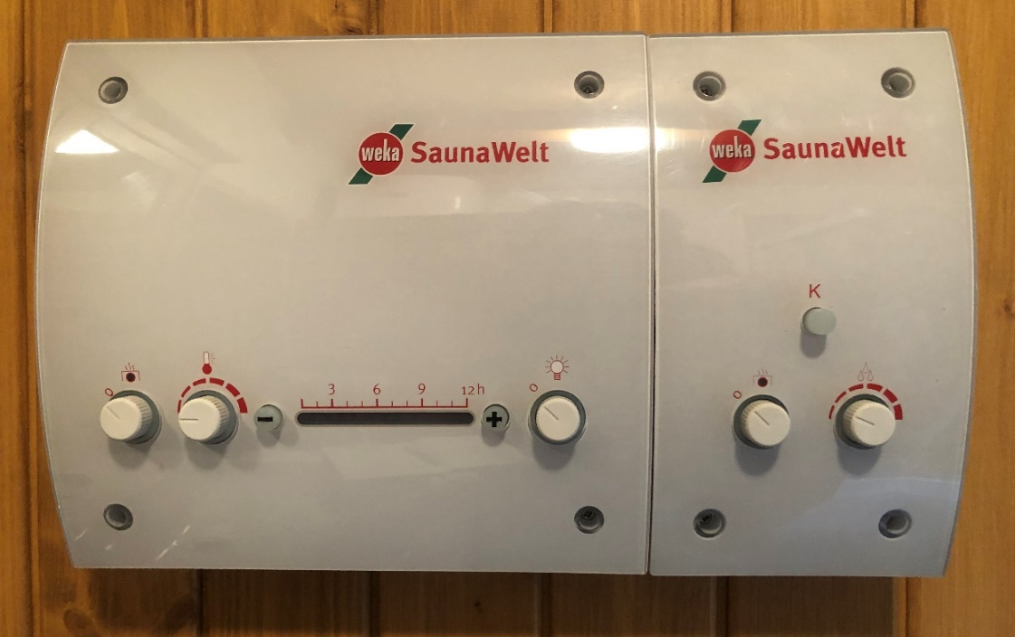
The Finnish Sauna
The Turkish Sauna

THE TURKISH SAUNA
- Don’t turn on the sauna just yet. First fill up the chamber with water to the maximum height (it is located to the left of the stones inside the sauna). You open the lid and pour it in.
- Then you can turn on the sauna. If you want the Turkish sauna, you use the buttons on the right side of the console (shown in the picture). Turn the left key from 0 to the symbol of a lit oven. The symbol should turn red.
- Turn the next button far right halfway and the water in the sauna should start heating up. Temperatures should be between 42ᵒC and 45ᵒC
- FRAGRANCES AT THE TURKISH SAUNA ARE NOT ALLOWED. The stones are also not heated, so you don’t spill water on them.
- VACUUM CLEANER
The vacuum cleaner is in the master bedroom, behind the door.
Caution! Do not vacuum wet surfaces!

- USE OF THE FURNACE IN THE MAIN HOUSE

- First open the chimney you find the hook (turn it upwards) on the back of the chimney
- Then open the lower drawer. You do this with two hooks at the bottom of the furnace. Move them to the right. This is how you open the air supply.
- Stack the small firewood transversely so that there is room below for the heppo cube. Two vertically and the other transversely across these. The firewood should be dry, small and very thin.
- Then place thinner firewood and then thicker firewood on those.
- Light 1 or 2 heppo cubes and place under the small firewood you transversely placed
- Close the furnace
- When it starts to burn, you can close the air supply in the lower drawer. Leave the chimney open.
There is a fan that automatically turns on and off. You can also turn it off - on the left side in the back of the furnace

- STOVE IN PARTY BASEMENT
It is DEFECTIVE. Therefore, it is not allowed to be used. Thank you for your understanding.

- HOT WATER IN PARTY BASEMENT
Turn on the water heater on the left under the sink.

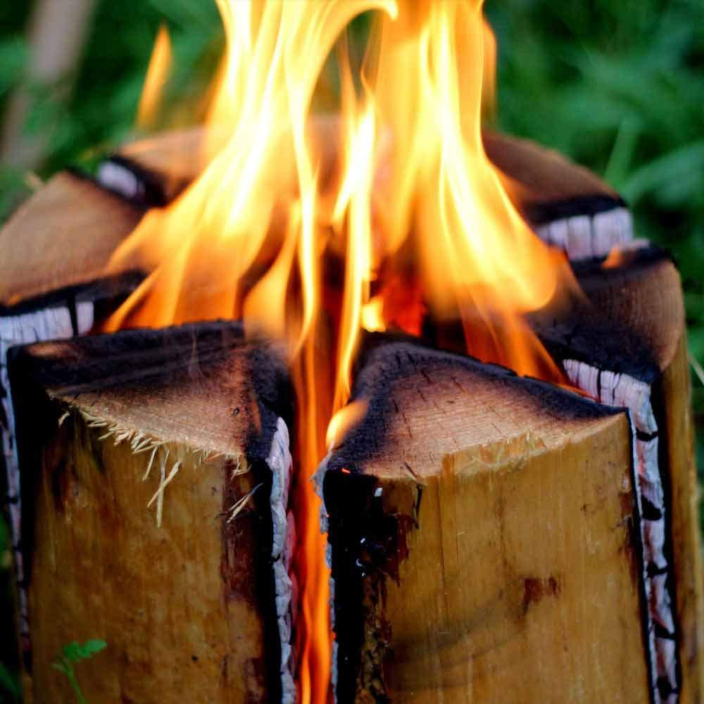
- USE OF THE SWEDISH TORCH

You can find them on the terrace. They should be at least 10 meters away from buildings and not too close to the forest. Place them in low grass. Push the heppo cube into the middle with a screwdriver and ignite with a gas lighter.

Enjoy

8. GRILL WEBER
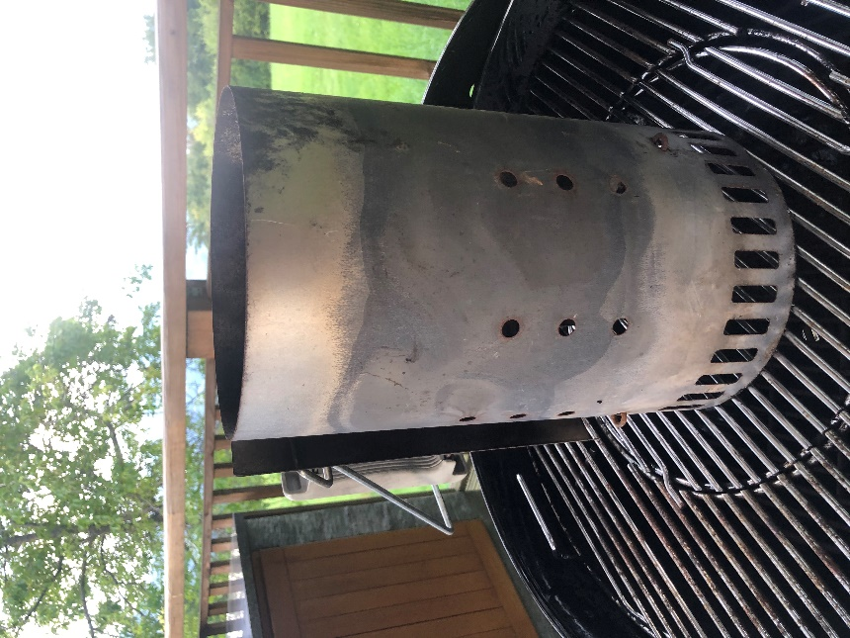
- Use a starter set (shown in the picture). Place one or two heppo cubes on the grill racks and place the starter set on it.
- Put charcoal in it (you find it under the sink). Fill it up to the top.
- Wait 15-20 minutes until all the briquettes light up and start glowing. On top as well.
- Lift the grate and distribute the charcoal evenly for a uniform temperature over the entire surface
- Place the hot starter set on a grass surface to cool

- Baking is always covered
- The temperature is regulated in two places: by the upper vent on the lid (open by rotating in one direction) and by rotating the handle below:
Instructions for the handle below:
- FAR LEFT closed; the temperature is minimal
- 2 and a half rounds half power
- RIGHT RIGHT open; temperature maximal
OIL THE GRILL RACKS FOR OPTIMAL TASTE
After use:
When the grill is still hot, rub and clean it with the brush.
Bon appetit

9. GARDEN FIREPLACE
- Remove the cover.
- Lay the thin firewood transversely so that there is room below for the heppo cube. It is recommended to have two vertically and the rest transversely
- First place the thinner and then the thicker firewood
- Light 1 or 2 heppo cubes and place them under the cracks
- You can put the lid back on

After use:
To turn off, use a glove and remove the cover. Also set aside the iron ring and place it on the grass surface. Place the cover back on the garden fireplace to completely stop the air supply.

10. WATER BOILER IN THE MAIN HOUSE
It is located in the bathroom behind the door on the right.
- From 0 (turn the key) to e for ignition
- Then step out of the bathroom and press the middle light button
- The red light on the boiler should light up

11. LOCKING
When leaving, lock all facilities. A special feature is on the door of the Party Basement. The door handle has to be turned upwards, strongly.

12. GARBAGE
Garbage is dumped in a landfill located at the following coordinates: 46ᵒ10'15''N 15ᵒ10'40''E
Or on the way back from the Forester's hut, you will find the nearest dump about 10 minutes away on the right.

